SAIT program training economic development experts

Smaller communities facing challenges
By Mario Toneguzzi, Calgary HeraldMarch 13, 2013
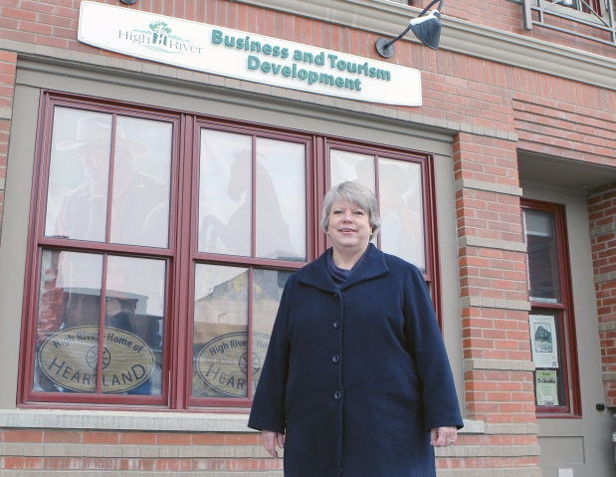

Judy McMillan-Evans, an instructor with the SAIT School of Business outside the Town of High River Business and Tourism Building.

Photograph by: Lorraine Hjalte , Calgary Herald
CALGARY — SAIT Polytechnic has developed and launched a Community Economic Development certificate program to help revitalize smaller communities that are facing many economic challenges with some even becoming ghost towns.
Janet Sainsbury, co-ordinator of distance education for the School of Business, said the new program is designed to develop the skills required to meet the challenges faced in small towns today.
“It is being offered by distance online or a combination of online and classroom courses—making this program accessible to anyone, anywhere at any time,” she said.
Judy McMillan-Evans, instructor as well as course and program developer at the SAIT School of Business, said communities are looking for a balance between jobs, tourism, economic opportunities, and lifestyle.
“The whole objective of economic development is to plan communities for a sustainable future, logical future. Therefore most rural municipalities whether they be a town, a city, a village or a rural municipal district, have economic development people on staff ... Every municipality wants to have a planned future,” said McMillan-Evans, who is also manager of projects and capacity building for the Community Futures Network of Alberta.
“Lots of small communities are struggling for survival and many rural communities or villages in particular in Alberta are really not sure . . . whether they’re going to exist in the future because the balance is no longer there in their economy or they’re struggling to keep that balance. So these kind of staff members are really critical because they can push and pull and help direct so that the community doesn’t just sit there and let the future happen where it’s going to happen. They try and find solutions and plans that are going to create a better future.”
CED specific courses at SAIT began in the fall.
Dwight Stanford, chief administrative officer for the Town of Strathmore, said economic development is very important for all towns and cities.
“It’s important that people get training in the field rather than just jumping in and saying ‘I know economic development’,” he said.
“As the prosperity business gets more complex, more skills are needed to be competitive. Programs like SAIT’s turn out engineers of economic growth who are totally focused on the community’s social and economic well-being.”
SAIT’s Community Economic Development program is closely aligned with industry as instructors are economic development professionals that bring extensive field experience into the curriculum. The certificate is a new program that has been approved by Alberta Advanced Education. It is the only one of its kind in Canada offering an online certificate in CED.
One of the key features of the program is that it ladders into other programs like a Business Administrative diploma – which leads to a business degree program.
“For all communities, no matter what size or where they are located, economic health is paramount and economic drivers always come from business activity,” said McMillan-Evans. “Most people enter the field of economic development accidentally and therefore, the knowledge of how to best support the new and existing businesses within a community is gained through trial and error — a long and expensive road.
“When we decided to develop a program that is totally focused on supporting businesses, SAIT researched all of the other programs in Canada and the U.S. and found programs focused on the social aspects of community but no learning programs focused on business development.”
© Copyright (c) The Calgary Herald

